

Regent Exams

Last Day

Box Lunch

Meat Sandwich

Popcorn

Cheese Stick

100% Vegetable Punch

Pears

Skim Chocolate & 1% White Milk Served Daily

**JUNE 2019**

SALMON RIVER CENTRAL SCHOOL DISTRICT

Popcorn Chicken

Chicken Stuffing

Dinner Roll

Broccoli

Applesauce

BBQ Rib on bun

French Fries

Baked Beans

Peaches

Bag Lunch

Bologna or Turkey Sandwich

Cheese Stick

Baby Carrots w/ ranch

Chips

100% Fruit Juice

Cookie

Fishburger/ Fish Nuggets

Macaroni and Cheese

Corn

Orange Smiles

Menu Subject to Change

Without Notice

USDA Is an Equal Opportunity Provider and Employer

Peanut products are no longer on the menu in the Salmon River District

**No School**



**No School**

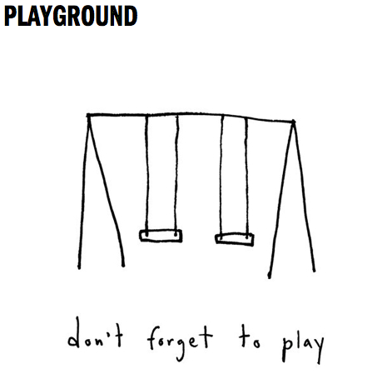

Regent Exams

Pizza

Tossed Salad

Celery Sticks w/ Ranch

Mixed Berries

Chocolate Chip Cookie

Regent Exams

Hot Dog on Bun

Hamburger on Bun

RF Doritos

Cheese Stick

100% Vegetable Punch

Applesauce

Regent Exams

Pizza Boat

Cooked Carrots

Apple Juice

Fruit Salad

Regent Exams

BBQ Baked Chicken

Macaroni Salad

Dinner Roll

Corn

Orange Smiles

Regent Exams

Buffalo Chicken Wrap

Turkey Sub

Caesar Salad

Fresh Broccoli w/ ranch

Baked Chips

Pears

Regent Exams

Hot Dog on Bun

Cole Slaw

Baked Beans

RF Dorito

Watermelon

Boneless Wings

Cheese Bread Stick

Marinara Sauce

Green Beans

Applesauce

Hamburg or Hot Dog

Macaroni Salad

Baked Chips

100% Sweet Potato Juice

Watermelon

Chicken Alfredo

With a Twist

Dinner Roll

Broccoli

Orange Smiles

Bologna Sub

Turkey Sub

Baked Chips

Tossed Salad

Celery Sticks

Tomato Slice

Fresh Fruit

BBQ Rib on bun

French Fries

Baked Beans

Peaches

Chickenburg on bun

Mashed Potato

Corn

Applesauce

Pizza

Tossed Salad

Celery Sticks w/ Ranch

Mixed Berries

Vanilla Pudding